INTEGRATION TESTING

Main Module: EntryController.java

Import Classes:

Carpark

ICarSensor

ICarSensorResponder

ICarpark

ICarparkObserver

IGate

IAdhocTicket

Implemented Class:

IEntryController.java

Number of methods: 14 and one constructor

Tested Status:

|  |  |  |  |
| --- | --- | --- | --- |
|  | | **Testing Status** | **Bug** |
| **Modules** | EntryController.java | Done | 12 error |
| **Implement Class** | IEntryController.java | Done |  |
| **Import Classes** | Carpark  ICarSensor  ICarSensorResponder  ICarpark  ICarparkObserver  IGate  IAdhocTicket | Done |  |

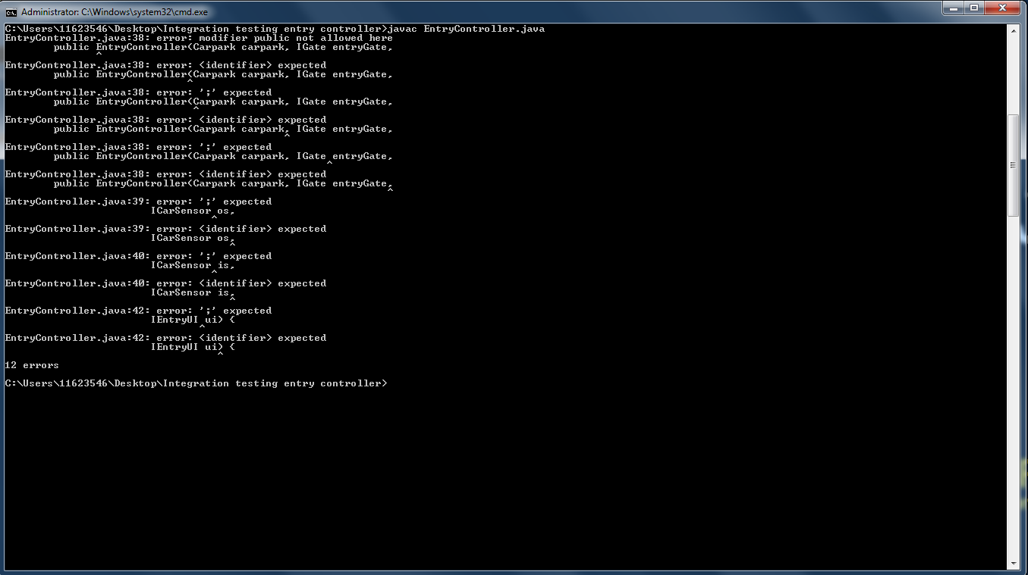

Prepared by: Rajinder Kaur